Login Program Specifications for ABC Asset Management Fund Fact Sheet Generator
Project ID
Project Name | ABC Asset Management Fund Fact Sheet Generator
Account
Business Unit / Global Account
Project Manager
Document Version Number | 1.0.0
Approved by:

Revision History
Version Number | Release Date | Description of Change/s made | Author  (Name & Role) | Reviewer  (Name & Role) | Approver  (Name & Role)
 | Mmm-DD-YY

Table of Contents
Revision History 2
1. Program Description 4
1.1 Unit Name, Version and Language used 4
1.2 Unit Description 4
2. Input Specifications 4
2.1 Files/Tables 4
2.2 Screen Layouts 4
2.3 Parameters Passed 4
2.4 Validations 4
3. Process Specifications 4
3.1 Program structure chart 4
3.2 Pseudo code 4
4. Output Specification 5
4.1 Files/Tables 5
4.2 Screen Layouts 5
4.3 Report Layouts 5
4.4 Parameters Passed 5
4.5 Output formatting 5
5. Performance 5
6. Security 5
7. Reuse or Third-party component 6

Program Description

Unit Name, Version and Language used

Unit Name: Login
Language used: C#

Unit Description

The program unit will allow only authorized users (i.e. fund manager) to login.

Input Specifications

Files/Tables

login
Field Name | Data type | Size | Constraints | Remarks
UID | Varchar | 50 | Primary Key
username | Varchar | 50
password | Varchar | 50

Screen Layouts
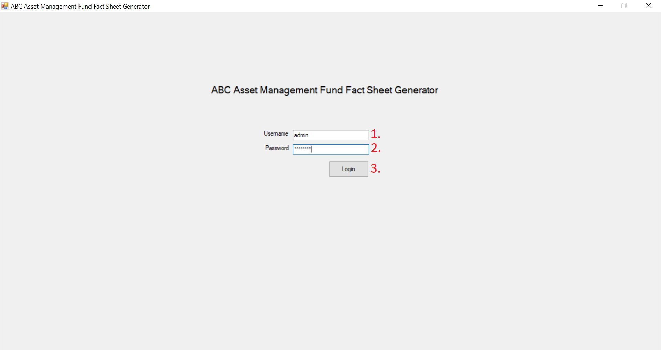

Parameters Passed

- There will be an empty text box for fund manager to input his user name.
- There will be an empty text box for fund manager to input his password. Inputted characters will be hidden.

Validations.

- A popup will appear on input of incorrect username/password combination. Only the correct username/password will allow the user entry into the main page.

Process Specifications

Program structure chart

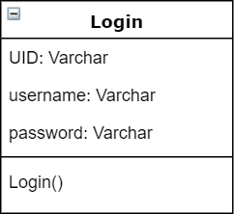

Pseudo code

Login
{
Open SQL Connection
Retrieve username and passwords that matches inputs.
If (username or password is null/empty)
{Show (“Invalid Credentials”)}
Else
{Go to main page}
}

Output Specification

Files/Tables

Screen Layouts

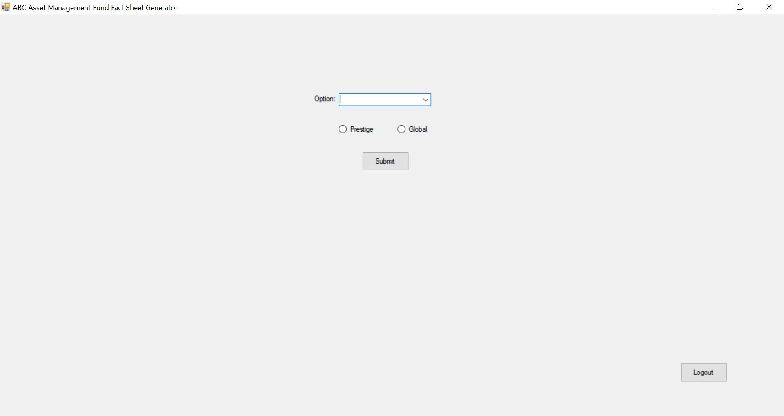

Report Layouts

Parameters Passed

Output formatting

Performance

Performance Requirements | Design | Constraints
Validation of login | Only valid username password combinations are allowed to login

Security

Application Areas | Login
Application Data | Password
Encryption in Transit/Storage | While typing, the password field is hidden

Reuse or Third-party component

External component | Module impacted | Assumptions and Constraints | Source/License

Template Revision History (For EPEX Use Only)
Version Number | Release Date | Description of Change/s made | Author  (Name & Role) | Reviewer  (Name & Role) | Approver  (Name & Role) | QMS Release Version
1.0 | NA | Initial baseline | NA | NA | SEPG | NA
2.0 | Jun-14-11 | Assigned artifact id, version #, release date to the template and modified Information Classification label in the footer | Shreevidhya Srinivasan, PM | Radhika Seenivasakan, SEPG | Rajesh Sreekumar, SEPG | 4.2
2.1 | Nov-30-18 | Modified SEPG references to EPEX as a part of Re-Org | Prakash Palaniswamy, EPEX | Pradeep Kumar Pullathil, HEAD, EPEX | Pradeep Kumar Pullathil, HEAD, EPEX | 7.5

